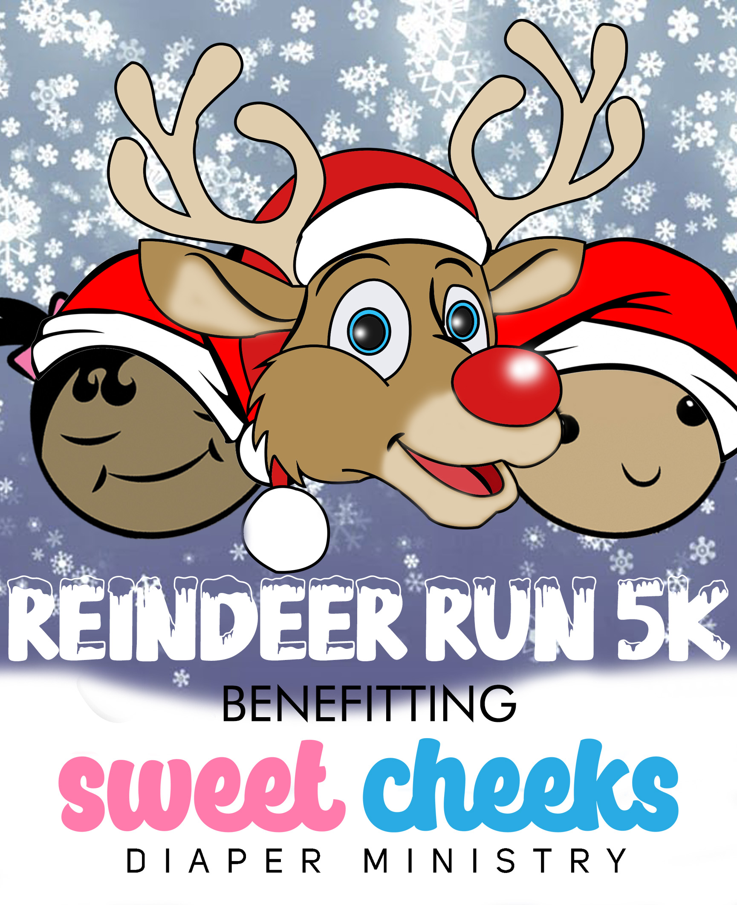
3rd Annual Reindeer Run 5K & Diaper Drive
Benefitting Sweet Cheeks Diaper Ministry
December 10, 2022

SPONSORSHIP PROPOSAL
We would like to invite your business to partner with Sweet Cheeks Diaper Ministry for our 3rd Annual Reindeer Run 5K & Diaper Drive to be held on Saturday, December 10, 2022 at Shelby Farms Park at 9:00 AM.
Sponsorship provides an ideal marketing opportunity for your business. We offer many levels of sponsorship and opportunities for involvement, as well as providing businesses with positive brand recognition. As a sponsor, you can be part of a fun athletic event that promotes health and awareness in our community and supports a local non-profit.
Race Overview
The Diaper Dash 5K is not only for competitive runners but also for families wanting to share a great outdoor experience. This will be our 3rd year hosting this one of a kind event in Memphis, with hopes to attract more competitors every year. The race will be held at Shelby Farms Park and features a lovely, inviting, and scenic course.
After the race, there is a 25-yard Kids Dash and Fun Zone where children will show off their speed, face painting, bounce houses, etc. This special event will be a huge hit with spectators and participants alike. Race website is https://bit.ly/ReindeerRun901

About Sweet Cheeks Diaper Ministry
Sweet Cheeks Diaper Ministry is The Mid-South Diaper Bank, providing diapers and other necessities to families in need every month. We have donated over 1 MILLION diapers to families in need since 2014. SCDM also provides formula, period supplies, adult diapers, etc. We are a one stop resource for families in need in the Mid-South. There is still a huge need, more and more families are experiencing poverty every day. Sweet Cheeks Diaper Ministry strives to ensure that every baby in the Mid-South has enough diapers to stay clean, healthy, and dry.

Sponsorship
Included below are the various levels of sponsorship available and the benefits. We welcome your consideration and would be happy to discuss sponsorship opportunities with you and how we can best meet your company’s specific needs. Join us and help make a meaningful difference in the health and lives of the children and families.
Platinum Sponsor - $5,000 (one available)
• Acknowledgement in Media Releases • Mention in radio/TV interviews
• Logo featured with link out • 8 kid registrations for Kids Dash
• Sponsor feature on local social media • Speak on stage - 3 minutes
• B+W company logo on event t-shirt • First right of refusal in category
• Guaranteed space for company booth • Recognition in annual report
(provided by sponsor)

Gold Sponsor - $2,500 (three available)
• Acknowledgement in Media Releases • Guaranteed space for company booth
• Logo featured with link out (provided by sponsor)
• Sponsor feature on local social media • 6 kid registration for Kids Dash
• Company name listed on event t-shirt • On stage recognition
• Recognition in annual report
Silver Sponsor - $1,500 (five available)
• Acknowledgement in Media Releases • 4 kid registration for Kids Dash
• Logo featured with link out • Verbal recognition on stage
• Sponsor feature on local social media • Recognition in annual report
• Guaranteed space for company booth
(provided by sponsor)

Bronze Sponsor - $1,000 (unlimited)
• Acknowledgement in Media Releases • Verbal recognition on stage
• Logo featured with link out • Recognition in annual report
• Sponsor feature on local social media
• Guaranteed space for company booth
(provided by sponsor)

Bib Sponsor - $750 (one available)
- Logo on race bibs
- Name on entry forms and posters
- Name included in all advertising and marketing efforts
- Name included on race banner
- Logo on the SCDM website
- Race-day recognition
- Invitation to provide item(s) for runner swag bag
Mile Marker Sponsor - $250 (three available)
- Logo on one of the mile markers
- Name on entry forms
- Name included in all advertising and marketing efforts
- Logo on the SCDM website
- Race-day recognition
- Invitation to provide item(s) for runner swag bag
Water Station or Finish Line Sponsor - $200 (two available)
- Logo on water station or finish line
- Name included in all advertising and marketing efforts
- Logo on the SCDM website
- Race-day recognition
- Invitation to provide item(s) for runner swag bag
Vendor -$150 (10 available)
- Set up your own 10' x 10' booth at race "after party"
- Race-day recognition

Contact Name _____________________________________________________________
Business Name ____________________________________________________________
Address ___________________________________________________________________
City _______________________________________ State ________ Zip _________________
Phone: ___________________________________ Fax: ________________________________
Email: ________________________________ Website ________________________________
Yes! I (we) will sponsor Reindeer Run 5K & Diaper Drive at the following level:
Platinum Sponsor ($5,000)
Gold Sponsor ($2,500)
Silver Sponsor ($1,500)
Bronze Sponsor ($1,000)
Bib Sponsor ($500)
Mile Marker Sponsor ($250)
Water Station or Finish Line Sponsor ($200)
Booth Sponsor ($150)
I wish to make a tax-deductible donation of $ __________________________
In lieu of a cash payment, I would like to make a product/service donation of
_____________________________________________ Value $ _______________________
Please complete this form and return with your check made payable to Sweet Cheeks Diaper Ministry.
Sweet Cheeks Diaper Ministry
PO Box 3352
Cordova, TN 38088
Note: To ensure inclusion on all marketing materials please return form and your check no later than November 15, 2022. To ensure inclusion on t-shirts, please return form and your check no later than November 1, 2022. If you would like to pay card, let us know and we’ll send an invoice. Questions? Please contact Cori Smith at cori.smith@sweetcheeksdiaperministry.org

