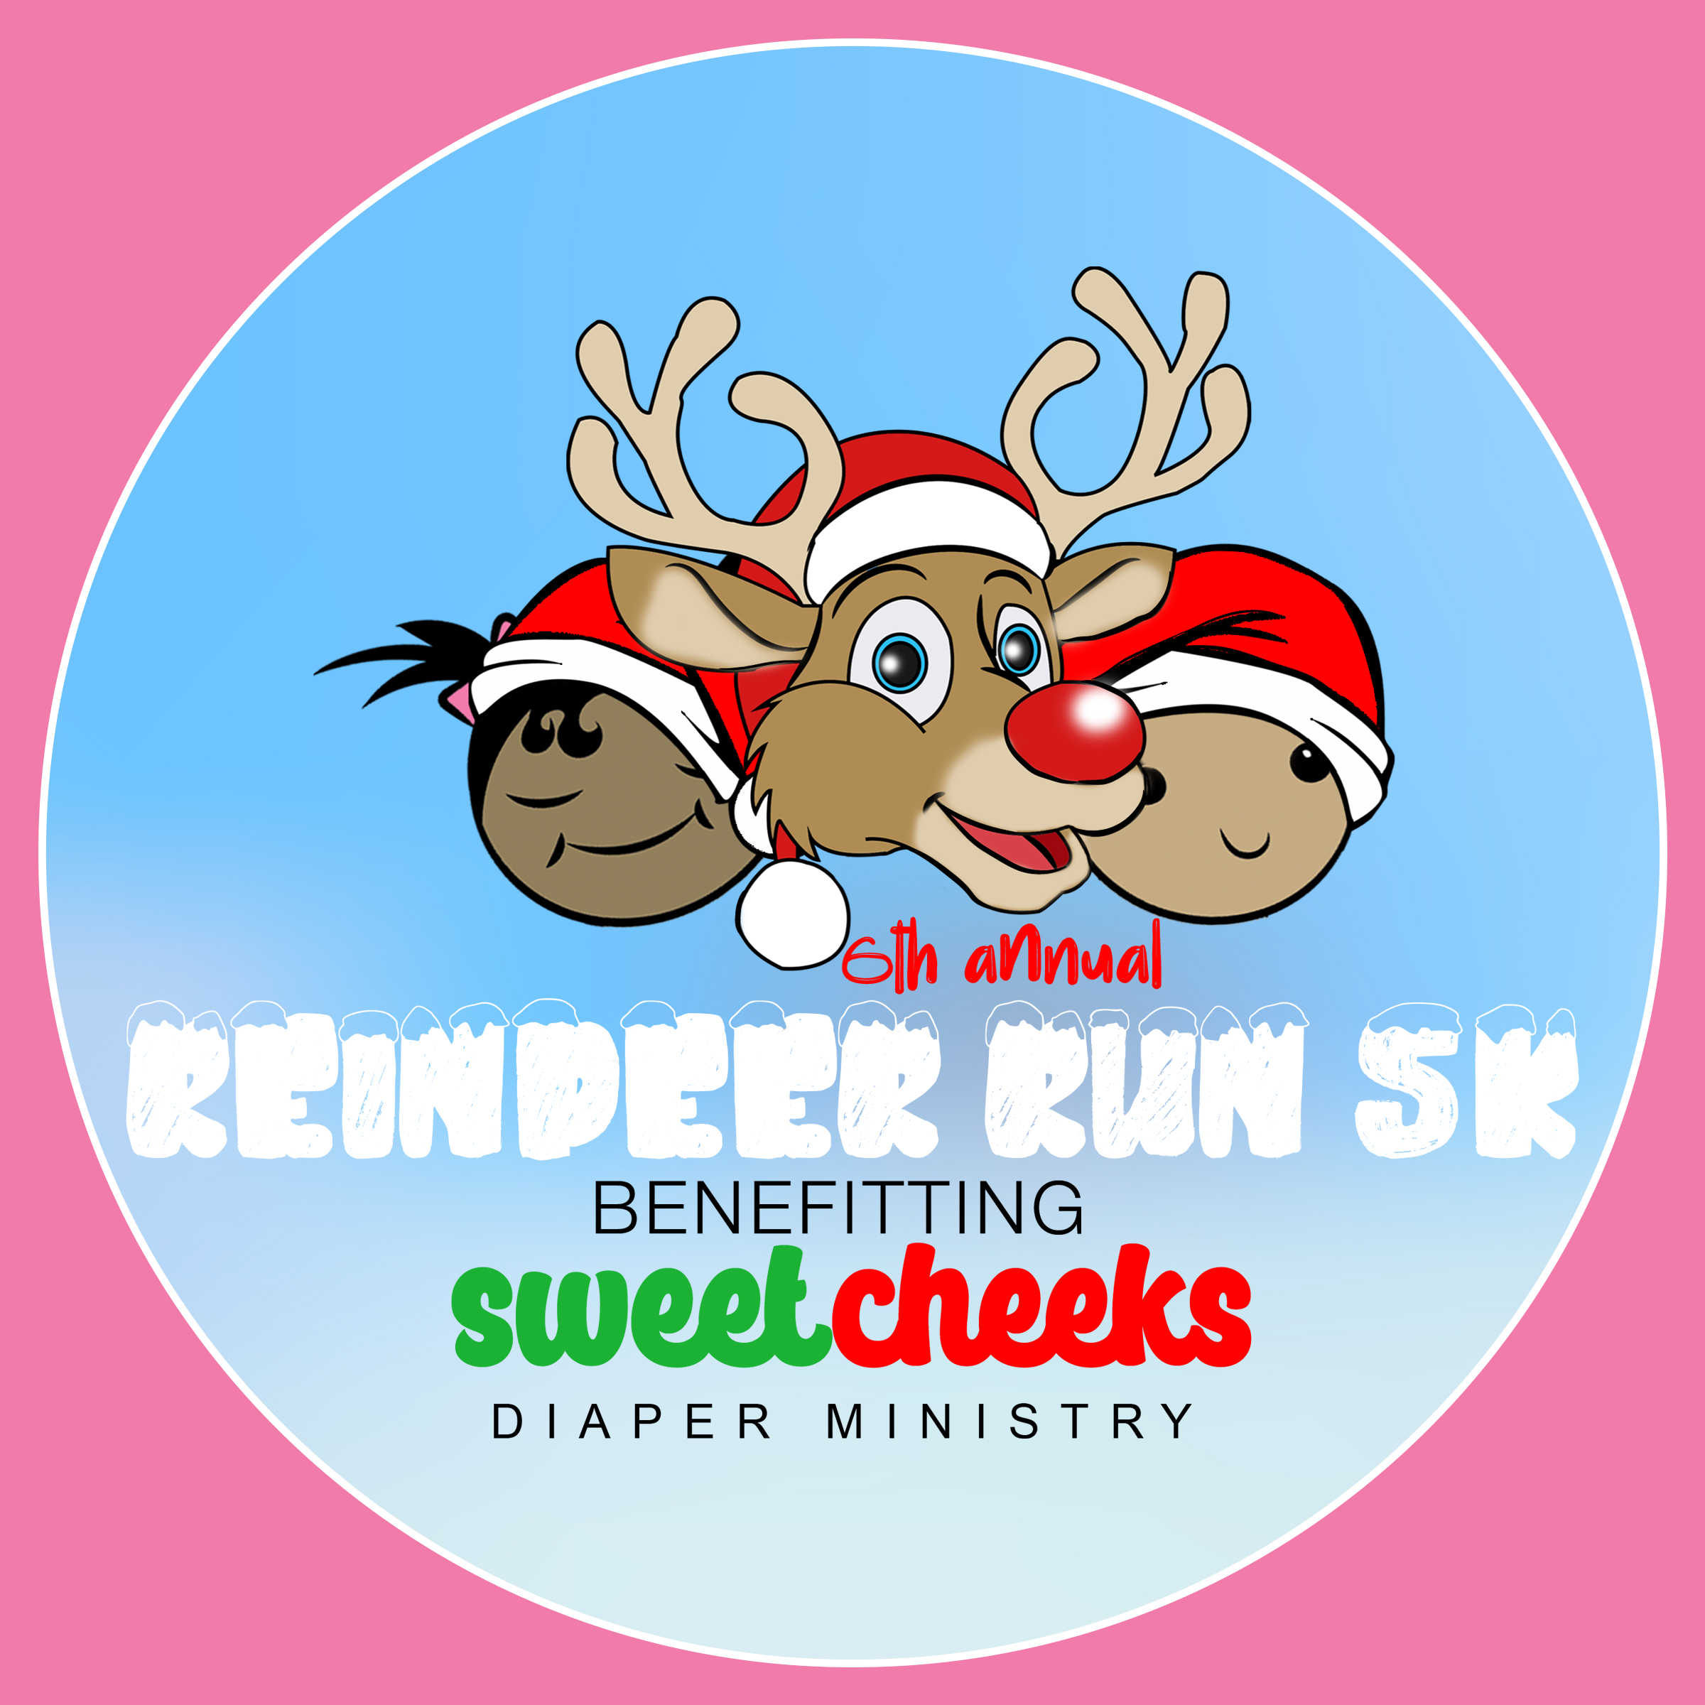
6th Annual Reindeer Run 5K & Diaper Drive
Benefitting Sweet Cheeks Diaper Ministry
December 20, 2025

SPONSORSHIP PROPOSAL
We would like to invite your business to partner with Sweet Cheeks Diaper Ministry for our 4th Annual Reindeer Run 5K & Diaper Drive, taking place on Saturday, December 21, 2024, at Shelby Farms Park at 9:00 AM. 🎄🏃‍♂️
Sponsorship offers an excellent marketing opportunity for your business, with various levels of involvement to choose from. This partnership will provide your brand with positive recognition while being part of a fun, athletic event that promotes health and awareness in our community. By supporting us, you'll be helping a local non-profit while making a meaningful impact!
Join us in spreading joy and support this holiday season! 🎅✨

Race Overview
The Reindeer Run 5K is designed for both competitive runners and families looking to share a fun outdoor experience! 🎄🏃‍♀️ This will be our 5th year hosting this unique event in Memphis, and we aim to attract even more participants each year. The race will take place at Shelby Farms Park, featuring a beautiful, scenic course that's perfect for all.
After the race, join us for a 25-yard Kids Dash and a Fun Zone, where children can show off their speed and enjoy face painting, s’mores, and more! 🍫🎨 And don’t miss a special visit from Santa this year! 🎅 This exciting event is sure to be a hit with both spectators and participants alike. Join us for a day full of fun, family, and community spirit! 🎉
For more information, visit our race website at https://bit.ly/ReindeerRun901.

Platinum Sponsor - $5000 (Category Exclusivity: +$1500)
• Acknowledgement in Media Releases • Mention in radio/TV interviews (if available)
• Logo featured with link out • 8 adult & 4 child registrations
• Sponsor feature on local social media • Speak on stage - 3 minutes
• B+W company logo on event t-shirt • Recognition in annual report
• Guaranteed space for company booth
(provided by sponsor)

Gold Sponsor - $2500
• Acknowledgement in Media Releases • Guaranteed space for company booth
• Logo featured with link out (provided by sponsor)
• Sponsor feature on local social media. • 6 adult & 3 child registrations
• Company name listed on event t-shirt. • On stage recognition
• Recognition in annual report

Silver Sponsor - $1000
• Acknowledgement in Media Releases • 2 adult and 2 child registrations
• Logo featured with link out • Verbal recognition on stage
• Sponsor feature on local social media • Recognition in annual report
• Guaranteed space for company booth
(provided by sponsor)

Bronze Sponsor - $500
• Acknowledgement in Media Releases • Verbal recognition on stage
• Logo featured with link out • Recognition in annual report
• Sponsor feature on local social media
• Guaranteed space for company booth
(provided by sponsor)

Vendor - $100
Vendors can setup and sell products to race participants. Must provide your own table.

Yes! I (we) will sponsor Reindeer Run 5K & Diaper Drive at the following level:
Platinum Sponsor ($5,000)
Gold Sponsor ($2,500)
Silver Sponsor ($1,500)
Bronze Sponsor (500)
Vendor ($150)
I wish to make a tax-deductible donation of $ __________________________
In lieu of a cash payment, I would like to make a product/service donation of
_____________________________________________ Value $ _______________________
To complete your Sponsorship or Vendor spot, fill out form and send to cori.smith@sweetcheeksdiaperministry. Invoice will be sent for payment.
If you would like to mail a check, please let us know. Checks can be sent to:
Sweet Cheeks Diaper Ministry
PO Box 3352
Cordova, TN 38088

Note: To ensure inclusion on all marketing materials please return form and your check no later than October 11, 2025. To ensure inclusion on t-shirts, please return form and your check no later than November 25, 2025.
Questions? Please contact Cori Smith at cori.smith@sweetcheeksdiaperministry.org or
Rosie Coleman at info@sweetcheeksdiaperministry.org.

