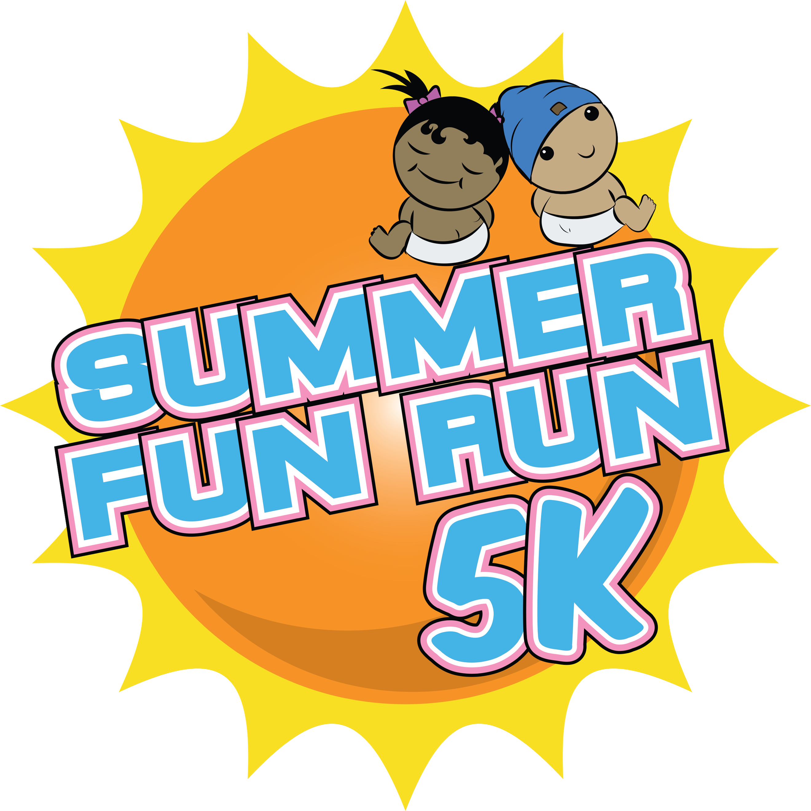

7th Annual Summer Fun Run 5K & Diaper Drive
Benefitting Sweet Cheeks Diaper Ministry
August 8, 2026

SPONSORSHIP PROPOSAL
We would like to invite your business to partner with Sweet Cheeks Diaper Ministry for our 7th Annual Summer Fun Run 5K & Diaper Drive, taking place on Saturday, August 8, 2026, at Shelby Farms Park – Hyde Lake Pavillion at 9:00 AM.
Sponsorship offers an excellent marketing opportunity for your business, with various levels of involvement to choose from. This partnership will provide your brand with positive recognition while being part of a fun, athletic event that promotes health and awareness in our community. By supporting us, you'll be helping a local non-profit while making a meaningful impact!

Race Overview
The Summer Fun Run 5K is designed for both competitive runners and families looking to share a fun outdoor experience! This will be our 7th year hosting this unique event in Memphis, and we aim to attract even more participants each year. The race will take place at Shelby Farms Park, featuring a beautiful, scenic course that's perfect for all.
After the race, join us for a 25-yard Kids Dash and a Fun Zone, where children can show off their speed and enjoy face painting, ice cream, and more! This exciting event is sure to be a hit with both spectators and participants alike. Join us for a day full of fun, family, and community spirit!
For more information, visit our race website at https://bit.ly/summerrun5k

Platinum Sponsor - $5000 (Category Exclusivity: +$1500)
• Acknowledgement in Media Releases • Mention in radio/TV interviews (if available)
• Logo featured with link out • 8 adult & 4 child registrations
• Sponsor feature on local social media • Speak on stage - 3 minutes
• B+W company logo on event t-shirt • Recognition in annual report
• Guaranteed space for company booth
(provided by sponsor)

Gold Sponsor - $2500
• Acknowledgement in Media Releases • Guaranteed space for company booth
• Logo featured with link out (provided by sponsor)
• Sponsor feature on local social media. • 6 adult & 3 child registrations
• Company name listed on event t-shirt. • On stage recognition
• Recognition in annual report

Kid’s Dash Sponsor - $1000
• Acknowledgement in Media Releases • 2 adult and 2 child registrations
• Logo on kid’s shirt with featured with link out • Verbal recognition on stage
• Sponsor feature on local social media • Recognition in annual report
• Guaranteed space for company booth
(provided by sponsor)

Bib Sponsor - $500
• Acknowledgement in Media Releases • Verbal recognition on stage
• Logo on race bibs with featured with link out • Recognition in annual report
• Sponsor feature on local social media
• Guaranteed space for company booth
(provided by sponsor)

Yes! I (we) will sponsor Summer Fun Run 5K & Diaper Drive at the following level:
Platinum Sponsor ($5,000)
Gold Sponsor ($2,500)
Kid’s Dash Sponsor ($1,000)
Bib Sponsor ($500)
I wish to make a tax-deductible donation of $ __________________________
In lieu of a cash payment, I would like to make a product/service donation of
_____________________________________________ Value $ _______________________
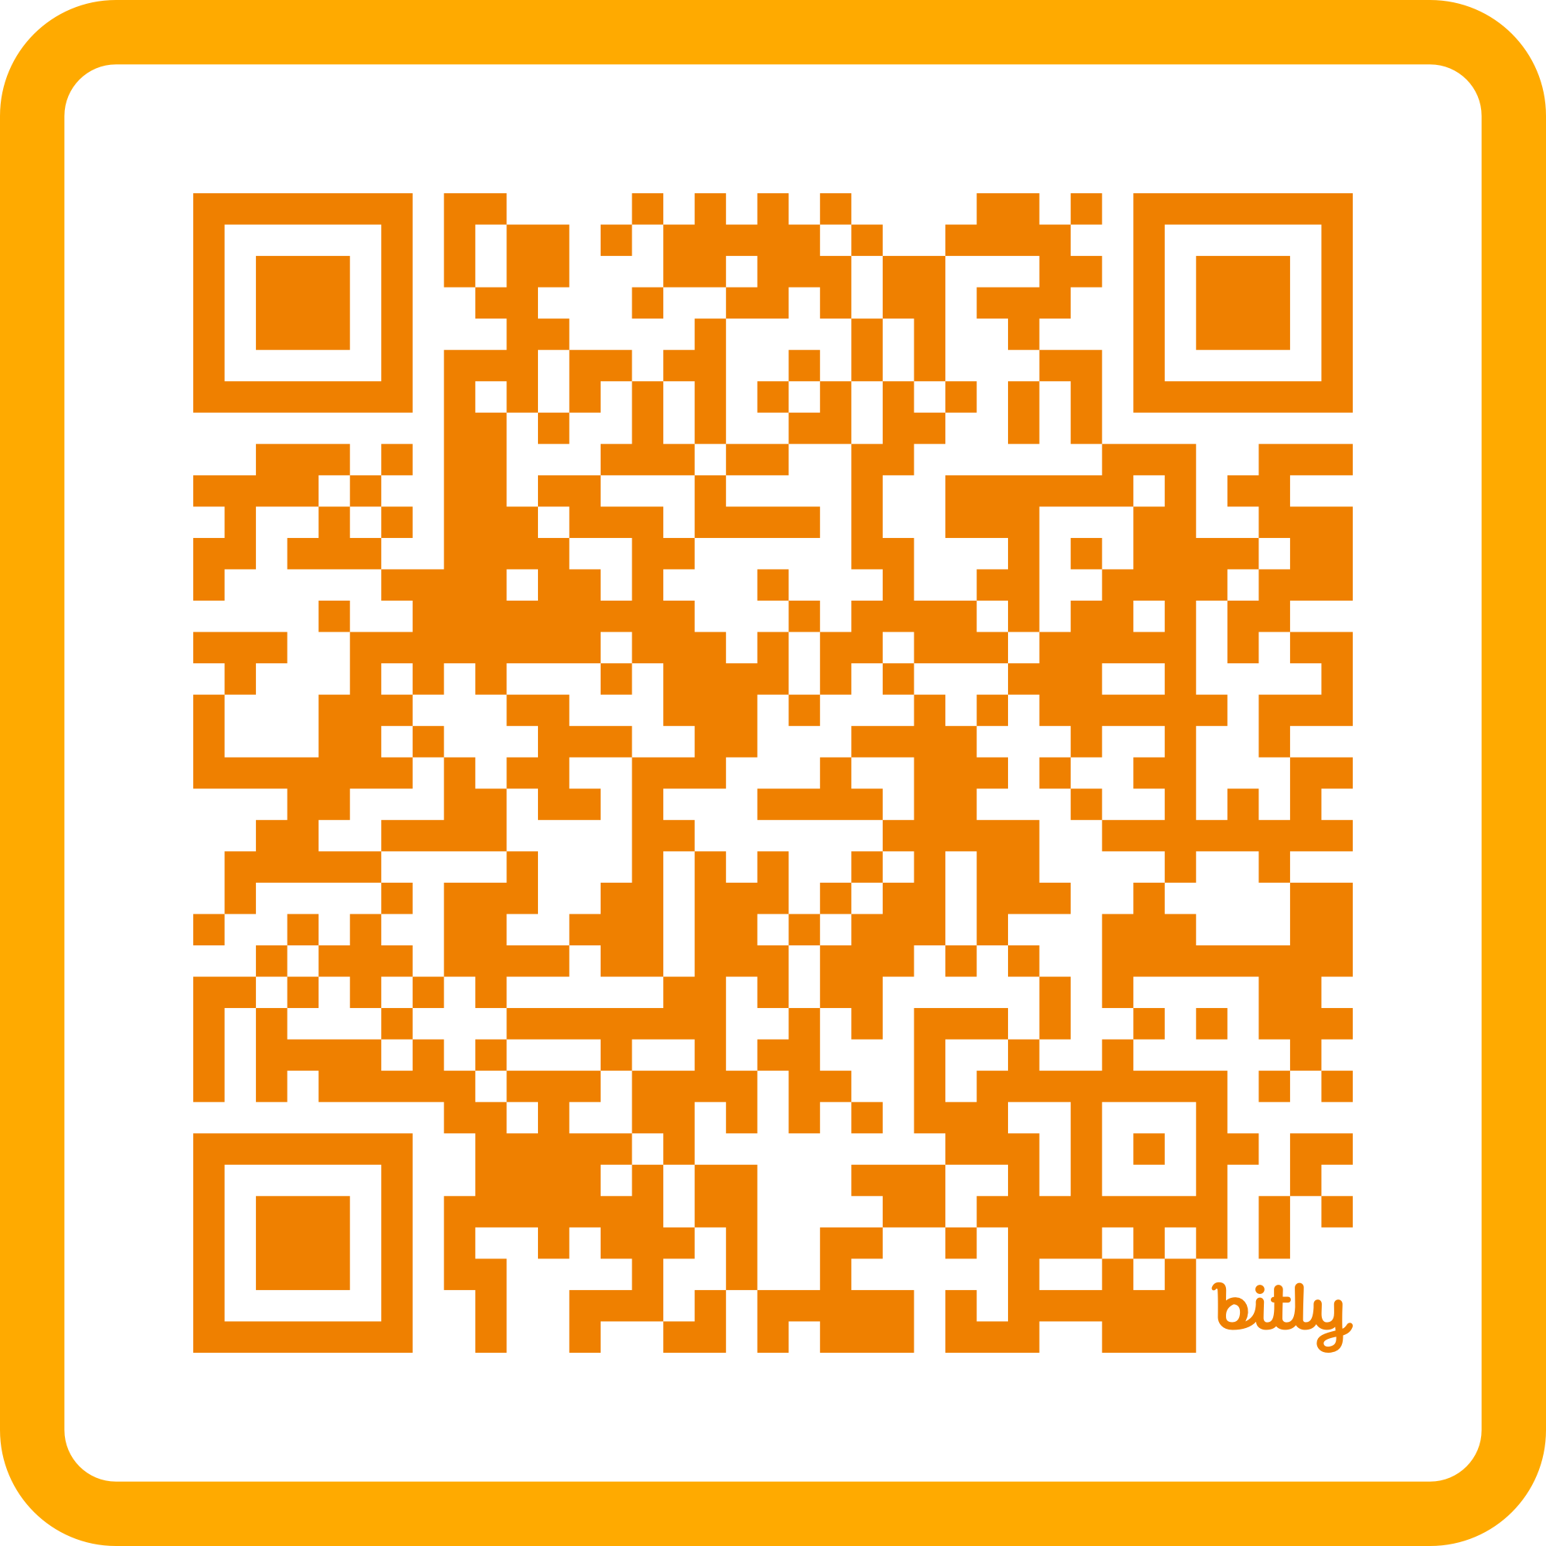
To complete your Sponsorship, fill out form and send to cori.smith@sweetcheeksdiaperministry.
Payment can be made at https://scdm.events/summerfunrun5k or scan code

Note: To ensure inclusion on all marketing materials please return form and your check no later than June 1, 2026. To ensure inclusion on t-shirts, please return form and your check no later than July 1, 2026.
Questions? Please contact Cori Smith at cori.smith@sweetcheeksdiaperministry.org or
Rosie Coleman at info@sweetcheeksdiaperministry.org.

